Test Project

Test Date

**Date**

Open Plan Dwelling Layouts - CFD Modelling Report

www.firedynamicsgroup.com

Fire Dynamics Group

Test Client

**Client**

Version History

|  |  |  |  |  |
| --- | --- | --- | --- | --- |
| Revision | Description | Date | Author | Checked by |
| 00 | First Issue, for comment | Test Date | Test Author |  |
| 01 |  |  |  |  |
| 02 |  |  |  |  |
| 03 |  |  |  |  |

Fire Dynamics

WeWork

71-91 Aldwych

London

WC2B 4HN

UK

|  |
| --- |
| Fire Dynamics Group Ltd  13476929 |

sam@firedynamicsgroup.com

This document is confidential and for the exclusive benefit of the client. It may not be assigned to or relied upon by a third party without the agreement of the client. However, this strategy report may be used by the end user of the building in the development of any fire safety management procedures and plans considered necessary to fulfil their responsibilities under applicable fire safety legislation.

Table of Contents

Version History 1

1. Introduction 4

2. CFD Modelling Approach 5

2.1. Overview 5

2.2. Modelling Software 5

3. NHBC/BRE Study: Open Plan Design and BS 9991 6

3.1. Overview 6

3.2. BS 9991 7

3.3. Proposed Design 7

4. CFD Model Properties 8

4.1. Fire Scenarios 8

4.2. Model Geometry 8

4.3. Fire Type 10

4.4. Fire Size 10

4.5. Sprinkler System Properties 12

4.6. Smoke Detector Properties 12

4.7. Door Leakage Rates 13

4.8. Ventilation and Make-Up Air 13

4.9. Mesh Sizing 13

4.10. Measurements 13

4.11. Slice Files 14

5. Evacuation Model 15

5.1. Overview 15

5.2. Detection Time 17

5.3. Pre-Movement Time 17

5.4. Occupant Location and Travel Distance 18

5.5. Travel Speed and Willingness to Travel Through Smoke 19

5.6. Simulation Time 20

5.7. Number of Runs 20

6. Tenability Criteria and Failure Categorisation 21

6.1. Parameters 21

6.2. Failure Categorisation 21

7. Event Trees 22

7.1. Introduction 22

7.2. Fire Burns Out at Early Stage 22

7.3. Door Between Fire Room and Escape Route Being Left Open (Code Compliant Cases Only) 22

7.4. Sprinkler System Operates (Proposed Design Cases Only) 22

7.5. Summary 22

8. Results and Discussion 24

8.1. Overview 24

8.2. Results – Apartment 1 24

8.3. Discussion: Apartment 1 0

8.4. Results: Apartment 2 **Error! Bookmark not defined.**

8.5. Discussion: Apartment 2 **Error! Bookmark not defined.**

9. Conclusions 1

9.1. Summary 1

9.2. Conclusion 1

10. References 2

Appendix A - Heat Release Rate Graphs 4

A.1. Apartment 1 – Fire in the Living Area **Error! Bookmark not defined.**

A.2. Apartment 2 – Fire in the Living Area **Error! Bookmark not defined.**

Appendix B - Detailed Results Graphs 5

B.1. Apartment 1: CC1 5

B.2. Apartment 1: CC2 5

B.3. Apartment 1: PD1 5

B.4. Apartment 1: PD2 5

B.5. Apartment 2: CC1 **Error! Bookmark not defined.**

B.6. Apartment 2: CC2 **Error! Bookmark not defined.**

B.7. Apartment 2: PD1 **Error! Bookmark not defined.**

B.8. Apartment 2: PD2 **Error! Bookmark not defined.**

Appendix C - Step By Step Calculation of Occupant Location Probabilities 6

Appendix D - FED Calculation Approach 8

D.1. FED – Heat (Smoke Temperature and Radiative Heat Flux) 8

D.2. FED – Smoke Toxicity 8

Appendix E - Sprinkler Activation Time Calculations 10

E.1. Objectives 10

E.2. Fire Location and Properties 10

E.3. Sprinkler System Properties 10

E.4. Calculation of Smoke Layer Temperature (Zone Model) 10

E.5. Calculation of Sprinkler Activation Time 12

E.6. Calculation of Corresponding Heat Release Rate 13

E.7. Peak Heat Release Rates 13

Appendix F - Determination of Worst-Case Scenario **Error! Bookmark not defined.**

F.1. Overview **Error! Bookmark not defined.**

F.2. Results, Discussion and Conclusion **Error! Bookmark not defined.**

1. Introduction
   * 1. Fire Dynamics has been appointed to provide fire safety engineering support for the proposed Test Project development. The design features dwelling layouts exceed the spatial constraints of the guidance of BS 9991[9] For open plan dwelling layouts. As such, this report has been prepared to demonstrate that the level of safety achieved by the proposed dwelling layout is at least as high as an equivalent code compliant design and, as such, can be considered to meet the functional requirements of Part B1 of the Building Regulations 2010[2].
     2. Specifically, the objectives of this report are to:

* Measure the risks to life safety in the proposed design, where a suppression system and enhanced detection is provided but habitable spaces open to the escape routes from the bedrooms;
* Measure the risks to life safety in a comparable code compliant dwelling design which incorporates a protected entrance hall;
* Using a semi-probabilistic approach, compare the relative risks to life safety in both design options; and
* Using event trees, determine whether the proposed design arrangements provide a higher measure of fire safety.
  + 1. The report has been prepared as part of an overall Building Regulations submission and should be read in conjunction with all other supporting documentation prepared and submitted by the design team.

1. CFD Modelling Approach
   1. Overview
      1. The methodology is comparative and uses a hybrid deterministic and probabilistic approach to compare fire safety levels, in line with the general approach of the NHBC/BRE research[3] into this subject discussed in Section 3 of this report. Safety levels are quantified using CFD and an evacuation model that incorporates distribution curves for evacuation times, potential occupant locations and occupant behaviour.
      2. For each design option (proposed and equivalent code compliant), CFD models are used to measure the conditions during the escape period for multiple fire scenarios within the flats. This data is then used to assess whether escape is possible for occupants in all possible combinations of pre-movement time and starting location, which in turn allows a probability of successful escape to be calculated for each fire scenario.
      3. The relative risks to life safety are then calculated using event trees to determine whether the proposed design can provide a higher measure of fire safety than its code-compliant counterpart, which in this case is an apartment which features no fire suppression system and a protected entrance hall. Each event tree considers the frequency and consequences of various events, with consequences measured by calculating the probability of an occupant becoming trapped or harmed under the different fire scenarios.
      4. The results show that the proposed arrangement provides a comparatively higher measure of fire safety than the more standard protected entrance hall arrangement and, as such, the design is considered to satisfy the Part B1 (Means of Escape) requirements of Part B of the Building Regulations.
   2. Modelling Software
      1. The CFD analysis has been carried out using Fire Dynamics Simulator (FDS) Version 6.7.9[4]. The software is produced by the National Institute of Science and Technology (NIST), it has been extensively validated against both, real and laboratory type fires and is an industry standard.
      2. Information on model assumptions can be found in NIST Special Publication 1080 ‘Fire Dynamics Simulator (Version 6) - Technical Reference Guide[5].

1. NHBC/BRE Study: Open Plan Design and BS 9991
   1. Overview
      1. Partly in response to international influences, there has been a rapid increase in demand for open plan layouts with the only means of escape from a bedroom being via an unprotected route to the apartment exit. This type of layout is at odds with the traditional guidance for fire safety in AD-B[1].
      2. To ensure a more coherent approach and highlight potentially unacceptable risks, NHBC in partnership with the BRE carried out a detailed study to examine potential alternative design options for satisfying Part B of the Building Regulations.
      3. The study addressed apartment layouts, sizes, internal travel distances, enhanced detection options and the possible benefits of using residential sprinkler systems. In addition, the study addressed human implications, including reaction and response times for people escaping from the building.
      4. With each of the above in mind, deterministic and probabilistic approaches were combined into a series of scenario modelling. This modelling first involved categorising all events and processes that might take place during a fire as deterministic models. With these, probabilistic models representing the likelihood of each pre-determined event happening, including varying human behaviours, were developed. Then, in response to this modelling, the Monte Carlo technique was employed to compare the risks to life safety in each scenario model, taking into account the aforementioned probabilistic representation of each of the pre-determined events and processes.
      5. The research study comprised:

* A detailed literature review to establish the background to the issues of open plan flat layouts and to establish what fire safety systems are currently being used in the UK and internationally;
* A detailed review of various fire safety systems to identify which of them would be best in terms of meeting UK fire safety requirements; and
* An evaluation of the options using the BRE risk assessment model CRISP to determine the risk levels for selected open plan flats and their equivalent Approved Document B compliant designs.
  + 1. A summary of the modelling cases is given in Table 1.

|  |  |  |  |  |  |
| --- | --- | --- | --- | --- | --- |
| **Case** | **Bedrooms** | **Configuration** | **Footprint\*** | **Alarms** | **Sprinklers** |
| 1a | One (Studio) | AD B compliant | 8m x 4m | LD3† | No |
| 1b | One | Open plan / inner room* | 8m x 4m | LD1$ | No |
| 1c | One | Open plan / inner room* | 8m x 4m | LD1$ | Yes |
| 2a | Two | AD B compliant | 10m x 8m | LD3† | No |
| 2b | Two | Open plan / inner room | 10m x 8m | LD1$ | No |
| 2c | Two | Open plan / inner room | 10m x 8m | LD1$ | Yes |
| 3a | Three | AD B compliant | 16m x 12m | LD3† | No |
| 3b | Three | Open plan / inner room | 16m x 12m | LD1$ | No |
| 3c | Three | Open plan / inner room | 16m x 12m | LD1$ | Yes |

Table 1: Summary of CRISP modelling results in NHBC/BRE Study

* Ceiling height is 2.25m in all cases.

* 9m travel distance measured to back of inner room case.

† LD3 system, smoke alarm in the circulation space only.

$ LD1 system, smoke alarm in each room.

* + 1. The results of the comparative exercise suggested that the open plan arrangements with enhanced detection (Cases 1b, 2b, 3b) could provide a comparable level of fire safety to that suggested in Approved Document B (Cases 1a, 2a, 3a). The arrangements with enhanced detection and a residential sprinkler system (Cases 1c, 2c, 3c) would produce an enhanced level of safety.
    2. The conclusions of the study were summarised as:
* The results indicated that open plan flats with a sprinkler system (in accordance with BS 9251[6] or BS EN 12845[7], as appropriate) and enhanced detection system (LD1 system in accordance with BS 5839-6[8]) could provide a level of safety that is at least as good as that of a similar AD-B compliant design.
* Maximum travel distances were shown to be an insignificant factor (up to the largest considered apartment size of 12m x 16m).
* It was not possible to state with sufficient confidence that enhanced detection alone could satisfy the requirements of the Building Regulations (Part B).
* It was stated that a fire engineered solution should consider all aspects of the whole fire system, including fire growth, smoke movement, smoke detection, suppression, human behaviour and interactions between them.
* It was noted that without consideration of human behaviour, depending on the scenario, fire models might not give an adequate measure of the risk.
* The conclusions were not deemed applicable to larger flats than that examined, multiple level apartments, designs with water mist and other fire suppression systems, designs with an open kitchen close to the front door and designs with self-closing doors on inner rooms.
* The modelling that formed the basis of these conclusions assumed that all active fire safety measures would be maintained in accordance with their recognised standards to achieve appropriate levels of performance and reliability.
  1. BS 9991
     1. The results of the NHBC study were later incorporated into BS 9991. Thus, it is now possible to design open plan flat layouts without approval risk, providing the caveats in BS 9991 are adhered to.
  2. Proposed Design
     1. The proposed dwelling design at Test Project does not meet the guidance given in BS 9991 as it and features an open kitchen where the area of the apartment exceeds 8m x 4m.
     2. It should be noted that the NHBC/BRE study does not conclude that arrangements such as this are unsafe. Rather, the limitations to open plan dwelling arrangements in BS 9991 reflect the geometry and arrangement of the flat types studied in the NHBC/BRE study. Given this, the purpose of this report is to study whether an open plan dwelling which exceeds the limitations of the guidance of BS 9991 can still be considered to provide a level of safety which is at least equivalent to a code compliant arrangement.
     3. The methods set out in this report are consistent with those in BS 7974[10]. Wherever possible, the same input data, methods, assumptions and acceptability criteria used in the BRE study have been adopted. These assumptions, along with all other data inputs are considered in detail in the sections which follow.

1. CFD Model Properties
   1. Fire Scenarios
      1. The report studies the consequences of a fire which starts within the open plan Kitchen area.
      2. **ENGINEER TO STATE WHY THIS FIRE LOCATION WAS CHOSEN**
      3. As part of the NHBC/BRE study, the BRE ran thousands of simulations for each layout studied and randomised the fire location in each. This allowed for all credible fire scenarios in each layout to be considered as part of the study to produce an overall or “absolute” level of safety associated with each design.
      4. This is not possible using the FDS software, as each individual fire model takes over a day to run, so running thousands of simulations would not be feasible. For this reason, only one “reasonable worst case” fire location has been studied and “relative” levels of safety are generated rather than “absolute” levels. This is not considered to impact the validity of the results as the other rooms where fire could occur (i.e. the bedrooms) are separated from the escape routes by a door and wall in both the code compliant and proposed design cases, and are provided with suppression in the proposed case. As such, it is reasonable to assume that should fire occur in these rooms, the level of safety would be higher in the proposed design case.
      5. Four separate FDS models have been run as a part of this study, these are:

* **(PD1): Proposed Open Plan Arrangement.** The proposed layout with no fire separation between the Kitchen and bedroom escape routes but with a suppression system and an enhanced detection system throughout. In this model, the suppression system is assumed to operate and extinguish the fire.
* **(PD2): Proposed Open Plan Arrangement.** This layout is the same as in PD1. However, in this scenario the suppression system fails to operate, allowing the fire to grow to a large size.
* **(CC1): Code Compliant Design.** removed
* **(****CC2): Code Compliant Design.** removed
  1. Model Geometry
     1. The geometry of the building has been recreated by scaling from the architectural layouts. Screenshots of the CFD models are provided in Figure 1 and Figure 2. Further descriptions of the models are provided in the sections which follow. The CFD modelling data, which shows the model layout in full, can be provided for review upon request.
     2. For the sake of simplicity, furniture was not included in the models. This is not considered to significantly affect the results as the height of furniture tends to be lower than the 1.7m reference height of the models. Any inaccuracies associated with this approach will equally impact both the comparative and proposed models so are assumed to cancel out.

Yellow Dots are Point Measurement Devices

HVAC Leakage “VENTS”

Green Dots are Smoke Detectors

Inlet Air Location

Blue Dots are Sprinkler Heads (PD1 only)

(Blue Dots) – PP1 Only

Fire Location – In PD2 the fire base size is larger

Figure 1: Model Geometry – Proposed Design Models PD1 and PD2

Green Dots are Smoke Detectors

Yellow Dots are Point Measurement Devices

Partition added to form protected entrance hall. In CC2, the door is assumed “closed” with the gaps modelled as HVAC Leakage Vents

Inlet Air Location

Green Dots are Smoke Detectors

HVAC Leakage “VENTS”

Fire Location

Figure 2: Model Geometry – Code Compliant Design Models CC1 and CC2

* + 1. All surfaces within the model are assumed to have the thermal properties of a double layer (25mm thick) of gypsum board. The thermal properties have been taken from Quintiere[19] as follows:
* Density: 1440kg/m3
* Specific Heat Capacity: 0.84 kJ/kg/K
* Thermal Conductivity: 0.48 W/m/K
  + 1. Whilst this is a simplification, it is considered that omitting minor variations to the thermal properties of the surfaces throughout the compartment will have a negligible effect on the results. Any inaccuracies associated with this approach will equally impact both the comparative and proposed models so are assumed to cancel out.
  1. Fire Type
     1. The fire load that was chosen is based on the fire load composition for a “TV Room” given in the journal article "Fire Load Survey of Historic Buildings" taken from the Journal of Fire Protection Engineering, Vol 17.2, May 2010[11] with stoichiometry/soot yield values for the various fuel types taken from the SPFE handbook[12]. The figures used for all simulations are given in Table 2.
     2. The chosen fire type is considered typical of that which may occur in a lounge in a residential premise. Whilst it is recognised that an oil pan fire would likely initially have a lower soot yield than a lounge fire, once the fire spreads to the surrounding cabinets etc., as would be expected for the larger fires, it is considered that the fuel load would be broadly similar to that modelled. The fuel properties chosen provide a credible test case for each of the design options, it is not intended to provide “worst case” values. Given the comparative nature of the study, increasing or decreasing the soot yield and toxicity of combustion products would equally impact the results in all models.
     3. It should be noted that the report of the NHBC study only discusses the pre-determined item types likely to be found within an apartment, that may or may not set alight in any specific scenario model. It does not provide in depth information about the type of fire load represented by these item types, or the assumed products of combustion and their yield values. Therefore, for this study it has been deemed appropriate to use a best practice approach with supported research and guidance documentation.

|  |  |  |  |  |  |  |
| --- | --- | --- | --- | --- | --- | --- |
| **Carbon**  **Atoms** | **Hydrogen Atoms** | **Oxygen Atoms** | **Nitrogen Atoms** | **Soot Yield (g/g)** | **CO Yield**  **(g/g)** | **Heat of Combustion (MJ/kg)** |
| 3.434 | 6.191 | 2.483 | 0.017 | 0.016 | 0.0064 | 1.807 |

Table 2: Combustion Products

* 1. Fire Size
     1. Two different fire sizes (controlled and uncontrolled) have been simulated as part of this analysis. The properties of each fire type are shown in Table 3.
     2. In the PD1 models, the fire is assumed to grow continuously until the suppression system is activated. The activation time of the sprinkler system has been calculated by hand, using the calculation method described in Appendix E. These calculations found a “worst case” activation time of 185 which equates to a peak heat release rate at sprinkler activation of 402kW. Upon activation of the sprinkler system, the fire then begins to diminish at a linear rate where the heat release rate (HRR) reaches zero after approximately 120 seconds (i.e. the fire is extinguished). This approach is identical to that adopted in the study carried out by NHBC/BRE, which assumed that sprinklers will always extinguish the fire once they have operated. As such, this approach is considered suitable for use in this study and can be supported by the fact that any instances where this may not occur (e.g. shielded fire, suppression failure) are covered by the results of the PD2 models.
     3. In the PD2, CC1 and CC2 models, the fire is uncontrolled by suppression and is assumed to be able to grow to a large size. This is in line with the approach used in the NHBC/BRE study for unsprinklered fires, which assumed that the fire would continue to grow within a room until it reaches 80% of the floor area or flashover occurs. In this study, the unsprinklered fires are assumed to grow to 1500kW before remaining at a steady state for the remainder of the simulation. Whilst it is recognised that the fires could potentially grow beyond this size, this limit has been placed to reduce the computational time required to run the models (larger fires take longer to run). This approach does not affect the final results as the tenability criteria for “harm” (See Section 6) tend to be breached before the fire reaches its peak.
     4. It has been assumed that fires within a living space will grow at a fastgrowth rate (0.047Ws-2 – CIBSE Guide E[14]). For the NHBC/BRE study, the fire growth rate in each model resulted from applying the Monte Carlo technique on the various relevant deterministic sub-models (fire location, item type ignited, proximity to other items) and hence was not a fixed value. However, given that the fire growth rate value used is frequently supported in a variety of guidance documentation, it has not been considered necessary to assess the effect of a varying fire growth rate as part of this study.

|  |  |  |
| --- | --- | --- |
| **Fire Property** | **PD1** | **PD2, CC1 and CC2** |
| Fire Growth Rate (kWs-2) | 0.047 | 0.047 |
| Fire Area (m2) | 1.0 | 3.24 |
| Peak HRR (kW) | 402 | 1500 |
| HRRPUA (kW/m2) | 500 | {Other_HPUA}} |
| Peak HRR time (seconds) | 185 | 358 |

Table 3: Design Fire (Programmed) Properties

* + 1. The Heat Release Rate Per Unit Area of the fires (HRRPUA) ranges from 400-450kW/m2 (slight differences are due to having to “snap” the fire obstruction to the modelling grid). These values are mid-range of the 320-570kW/m2 range given in Table A.4 of BS 7974:1[15] for dwellings so are considered appropriate. In order to properly model flame heights and concentrated areas of smoke production during the growth stages of the fire. The fire is split into multiple “rings” of obstructions within the model, each with an independent RAMP function, as shown in Figure 3 below. Each ring is activated once the HRRPUA of the previous ring reaches the target HRRPUA. This means that flames and temperatures are concentrated at the centre of the fire obstruction during growth.

6

7

8

9

10

12

11

5

4

3

2

1

Figure 3: Illustration of “Rings” Used to Simulate More Realistic Flame Development in FDS

* + 1. The recorded heat release rates for each model are shown in Appendix A. In all models, the recorded heat release rate closely follows the programmed fire curve.
  1. Sprinkler System Properties
     1. The PD1 models include the provision of a domestic sprinkler system throughout the flats which will be designed in accordance with BS 9251. The modelling inputs for this system are provided in Table 4 and are based on the guidance of BS 9251 rather than a specific design for these flats. It is considered that any minor variations in head location etc. in the actual design will not adversely affect the results or conclusions of this study.

|  |  |
| --- | --- |
| **Element** | **Specification** |
| Sprinkler Spacing | BS 9251 compliant. |
| Activation Mechanics | Activation at 185 Seconds – See Section 4.4 and Appendix E |
| Flow rate (one head) | 49.05 L/min |
| Particle Velocity | 5.0 m/s |

Table 4: Sprinkler System FDS Inputs

* + 1. The sprinkler spray does not have any impact on the heat release rate of the fire, which is controlled by the FDS RAMP function. Rather, the purpose of introducing sprinkler heads into the model is to account for the cooling effect the sprinklers would have on the products of the fire.
  1. Smoke Detector Properties
     1. As the specification of the smoke detectors is unknown, the “default” properties for an ionisation smoke detector in Pyrosim have been used, with an obscuration threshold of 3.28%. Smoke detectors have been positioned in the model as per a “typical” BS 5839-6 arrangement. Slight differences between the locations / specifications of detector heads assumed in the model and the actual smoke detector locations / specifications are considered unlikely to have a significant impact on the results or conclusions of this report.
     2. In the code compliant arrangement (models CC1 and CC2), a category LD2 alarm and detection system (in accordance with BS 5839-6) is provided. This standard of detection features heads in the circulation spaces and the primary living space. The proposed design (models PD1 and PD2) features a category LD1 alarm and detection system which features detection in all rooms including the open plan areas. %- else %}In both the code compliant and proposed design options a category LD1 alarm and detection system (in accordance with BS 5839-6) is provided. This includes detection in all rooms except bathrooms.
  2. Door Leakage Rates
     1. In all models, the doors to the bedrooms, utility rooms and bathrooms were assumed to be closed. Whilst this may not be the case, this assumption presents the “worst case” test as the volume of the living area and escape route is at its lowest.
     2. The leakage paths around the internal doors were programmed into the model using “vents” on the inner and outer sides of the gap at the top, sides and bottom. Leakage was then simulated using the HVAC function in FDS. In the CC2 models, the leakage through the closed door between the living space and the protected entrance hall was modelled in the same way.
     3. The leakage areas of internal doors are calculated based on a gap of 4mm at the top and sides and a threshold gap of 10mm, as per the minimum requirements of BS 8214[16] for non-smoke sealed fire doors. The widths and heights of the doors were scaled from the drawings. The front door is assumed to have a 3mm gap at the base and a reduced leakage rates at the top and sides due to the presence of smoke seals.
  3. Ventilation and Make-Up Air
     1. Due to the way the combustion model operates in FDS, make-up air is required to provide oxygen to sustain combustion for sufficient fire sizes. The NHBC study provided make-up air by using a temperature model to simulate window breakage within the fire compartment, as follows:
* 0-10% breakage at 90°C;
* 30-70% breakage at 250°C to 350°C; and
* 100% breakage at 400°C to 600°C.
  + 1. For this analysis, make-up air has been provided by way of one low-level opening with an area of 2.5m2 (2.5m wide by 1m high) for the non-sprinklered fires (PD2, CC1 and CC2 models). A 1m x 1m opening is provided in the sprinklered fire models (PD1).
  1. Mesh Sizing
     1. The CFD model is divided into a number of small cells (mesh). Given the small and rather complex geometry of the model, a fine and uniform grid of 100mm x 100mm x 100mm has been used in all areas. This is stated to be an acceptable grid size for “smaller enclosures” and “near field” (which in this context, would be inside an apartment) in Section 13.2 of the SCA CFD guide[21].
  2. Measurements
     1. Point measurements have been distributed throughout the escape routes at ten locations 1.7m above floor height. 1.7m is the reference height adopted in the NHBC/BRE study so is considered appropriate for this study. These measurements record the following variables throughout the simulation at one second time intervals, for use in the evacuation model.
* Smoke Visibility (m)
* Smoke Temperature (C)
* Radiative Heat Flux (kW/m2)
* Carbon Monoxide Concentrations (kg/m3)
* Carbon Dioxide Concentrations (kg/m3)
* Air Humidity (mol/mol)
  + 1. Not all point measurement devices are located on the escape route of every room. Table 8 shows the point measurement device locations which are relevant for each room. The behavioural model only takes the maximum / minimum readings from all device locations associated with the room when determining whether an occupant can escape.

|  |  |
| --- | --- |
| **Room** | **Relevant Point Measurement Locations in CFD Models** |
| Bedroom 1 | 1, 2, 3, 4, 5, 6, 7, 8, 9, 10 |
| Living Room | 1, 2, 3, 4, 5, 6, 7, 8, 9, 10 |
| Kitchen | 1, 2, 3, 4, 5, 6, 7, 8, 9, 10 |

Table 5: Relevant Point Measurement Locations for Each Room

* 1. Slice Files
     1. Several slice files (sections) for smoke visibility (m) and smoke temperature (°C) have been incorporated into the model to allow for visual outputs at head height throughout the flats. These slices can be viewed using the CFD data which is available upon request.

1. Evacuation Model
   1. Overview
      1. As per the NHBC/BRE Study, a randomised behavioural model has been developed to determine the probability of successful escape in each fire scenario. The specific behavioural model used in the NHBC / BRE study (CRISP) is not commercially available and the report of the study only details some of the inputs used. As a result, a similar probabilistic behavioural model has been developed using a combination of the data provided in the NHBC / BRE study report supplemented by data from the BS 7974:6[17] where necessary. The inputs for the model are listed and justified in the sections which follow.
      2. In a residential setting, the time taken for an occupant to escape depends on a variety of factors, such as whether they are awake or asleep (pre-movement time), the room they are in when escape is attempted (travel distance and location of escape route relative to the fire) and their willingness to move through smoke. Typically in fire engineering assessments, a “worst case” is used, where the most conservative inputs are assessed against and similar or better results are assumed for less conservative cases. Such a “deterministic” approach is not appropriate in this case as:

* The “worst case” may be variable from model to model (e.g. in a sprinklered case, an occupant may be subjected to more severe conditions in the early stages of a fire prior to sprinkler activation, this is unlikely to be the case in a non-sprinklered scenario).
* When undertaking a comparative assessment, it can be acceptable for there to be a degree of “failure” associated with a design providing this risk is lower than in an equivalent code compliant design. Studying a single case with the most onerous inputs would likely just show that both cases “fail” and would not allow a comparison of the relative levels of success associated with each design.
  + 1. For this reason, a probabilistic approach to evacuation modelling has been adopted. Using this approach, 10,000 individual escape simulations are run for each model with the data generated by the CFD models used to determine whether an occupant is able to escape, is trapped by the fire or is harmed by the fire. In each escape simulation, the starting conditions (pre-movement time, distance from the exit and willingness to move through smoke) are randomised (weighted to statistical data). The large number of escape simulations allows every combination of possible escape conditions to be tested against one another with greater weighting applied to those which are more likely to occur.
    2. This process allows a probability of failure to be calculated for each model. These values are then fed into event trees to calculate the overall probability of an occupant becoming trapped or harmed for each fire scenario (see Section 7). Figure 4 is a flow chart which shows the step by step process the evacuation model follows. The values used in this model are outlined in the sections which follow.

Runs = Runs +1

Assign Occupant Travel Distance

Assign Occupant Pre-Movement Time

Assign Occupant Visibility Tenability Limit

Time = Pre-Movement Time + Detection Time

Runs = 0

Calculate FED Values for Heat and Toxicity

Yes

Are FED Values for Heat or Toxicity ≥1?

Occupants “Trapped” and “Harmed” +1. End Run

No

If Visibility is:

< Visibility Tenability Limit, No Progress

> 5m, Subtract 1.2m From Travel Distance

5m, > Visibility Tenability Limit, Subtract 0.3m From Travel Distance

Yes

Occupants “Escaped” +1. End Run

Does Time = 1200 seconds?

Occupants “Trapped” +1. End Run

No

Time = Time +1 Second

Yes

No

Does Remaining Travel Distance = 0?

No

Does Runs = 10,000?

Yes

Collate Results and End Calculation

Figure 4: Flow Chart of Evacuation Model

* 1. Detection Time
     1. The detection time for each model is taken from the CFD Modelling results, as shown in Table 5 below.

|  |  |
| --- | --- |
| **Scenario** | **Detection Time (s)** |
| CC1 | 58 |
| CC2 | 100 |
| PD1 | 27 |
| PD2 | 53 |

Table 5: Detection Times taken from FDS Models

* + 1. BS 7974:6 states that an “alarm time” should be considered in detection time calculations. Alarm time is the time taken for an alarm to operate once either heat or smoke has been detected. Where automatic smoke detection is the trigger for alarm activation, this can be considered immediate and is taken to be zero seconds in this study. Although not explicitly stated, it is assumed the same value was applied in the NHBC study.
  1. Pre-Movement Time
     1. Pre-movement time is broken down into two components:
* **Recognition Time:** Recognition time is the period elapsing between a sounder operating and occupants of the building responding to the alarm. This strongly relates to the occupancy type, its characteristics, and the type of warning system employed.
* **Response Time:** Response time is the time that elapses prior to a person making a move towards an exit. This is the most complicated variable of all parameters associated with this methodology as it strongly influenced by human behaviour which is difficult to quantify in residential buildings.

**Calculation of Pre-movement Time**

* + 1. Pre-movement times in residential buildings can vary significantly depending on the characteristics of a person, their state of awareness (awake or asleep) and the decisions they the make prior to evacuation (i.e. information gathering and decision making). In the NHBC/BRE Study, a range of recognition times and pre-movement actions were allocated a specific time delay and a probability of occurrence was allocated as part of the Monte Carlo process.
    2. In this study, a similarly probabilistic approach is adopted, whereby all pre-movement activities are captured using a distribution curve of pre-movement times. This is done using research data by Proulx which is reproduced in Table E.1 of BS 7974:6.
    3. Figure 6 provides a sample of pre-movement times from this research study, with each line on the graph representing the distribution derived from each experiment. These are plotted against the reported frequency of occurrence. Whilst there is significant variation there are also some consistent trends, namely:
* A delay of approximately 30 - 50 seconds always arises between activation of the fire alarm and the first occupants beginning to evacuate;
* The majority of the occupants respond and evacuate before 150 seconds have passed;
* At 600 seconds, nearly all occupants have started to evacuate from the building.

Figure 5: Pre-movement Time Distribution Curves for Residential Building (Plot of Distributions in Table E.1 BS 7974:6)

* + 1. In order to capture all possible pre-movement times in this study, an envelope of all pre-movement times has been created. This pre-distribution envelope curve is shown by the dotted red line in Figure 6.

Figure 6: Pre-movement Time Distribution Curve Used (Red Dotted Line)

* + 1. For each escape scenario, a pre-movement time is randomly assigned based on the values in this curve. This number is added to the detection time to give a time when the occupant begins their escape. The ability of the occupant to escape at that time is then assessed against the conditions on the escape route at that time, as calculated by the CFD models.
  1. Occupant Location and Travel Distance
     1. The distance an occupant is required to travel to escape depends on the room which they are escaping from. The probability of a room being in a particular room “type” has been calculated based on the same assumptions used in the NHBC/BRE study and is shown in Table 6 below. A step-by-step explanation of how these figures were derived from the NHBC/BRE data is provided in Appendix C. As per the NHBC/BRE study, the probability of an occupant being in a bathroom at the time of a fire is considered so small as to be negligible for the purposes of this study.

|  |  |
| --- | --- |
| **Room Type** | **Probability** |
| Bedroom | 0.51 |
| Lounge | 0.46 |
| Kitchen | 0.03 |

Table 6: Probability of an Occupant Being in a Particular Room Type Whilst at Home

* + 1. Where multiple rooms of the same type exist within the demise, these overall probabilities are divided by the number of rooms of that type. On this basis, the probability of an occupant being in each room of the flats when they are at home is given in the table below along with the travel distances from the door of that room (or edge of the room if an open plan area) to the front door. It is assumed that any time taken for travel within the room prior to escape forms part of the pre-movement time.

|  |  |  |
| --- | --- | --- |
| **Room** | **Probability of Occupant Being Present when Fire Starts** | **Travel Distance to Front Door (m)** |
| Bedroom 1 | 0.51 | 3.3 |
| Bedroom 2 | 0.51 | remove row!! |
| Bedroom 3 | 0.51 | remove row!! |
| Bedroom 4 | 0.51 | remove row!! |
| Bedroom 5 | 0.51 | remove row!! |
| Bedroom 6 | 0.51 | remove row!! |
| Living Room | 0.46 | 2.7 |
| Living Room 2 | 0.46 | remove row!! |
| Kitchen | 0.03 | 2.7 |
| Kitchen 2 | 0.03 | remove row!! |

Table 7: Probability of an Occupant Being in a Particular Room and Associated Travel Distances

* + 1. At the start of each escape scenario, a starting location is randomly assigned based on these probabilities with the associated travel distance used as the distance the occupant needs to travel to escape.
  1. Travel Speed and Willingness to Travel Through Smoke
     1. The speed at which an occupant will travel to an escape route is based on the visibility of the smoke. In the NHBC / BRE study, it was assumed that occupants will enter smoke and attempt to escape where the optical density is greater than 0.5m-1, which equates to a visibility reading of 2m (see Section 6.9 of the NHBC report). The same minimum visibility value is adopted for this assessment.
     2. In addition, Table I.1 of BS 7974:6 provides the following information on travel speeds in low visibility.

|  |  |
| --- | --- |
| **Visibility Reading** | **Effect** |
| >5m | Walking Speed = 1.2m/s |
| 5m < 3m | Walking Speed = 0.3m/s |
| 3m < 2m | 30% of Occupants do not continue, else 0.3m/s |

Table 8: Assumed Walking Speeds at Different Visibility Levels

* + 1. In order to account for the fact that not all occupants will continue to escape at visibilities between 2-3m, a “visibility tenability limit” of either 3m (30% chance) or 2m (70% chance) is assigned to the occupant at the start of each escape simulation.
    2. At one second time intervals during each escape simulation, the visibility within the escape route is taken from the CFD data with the following actions taken:
* If visibility is >5m, 1.2m is subtracted from the remaining travel distance; or if not
* If visibility is greater than the assigned visibility tenability limit (i.e. either 2m or 3m), 0.3m is subtracted from the remaining travel distance; or if not
* The remaining travel distance remains the same as the previous time step.
  + 1. If this incremental approach reduces the remaining travel distance to zero without the occupant having been subjected to untenable conditions during escape (See Section 6), the occupant is considered to have “escaped” and the escape simulation is stopped.
    2. This approach is a very similar means of considering the visibility of smoke to that used in the NHBC/BRE study, where walking speeds and willingness to travel are affected by the “degree of difficulty” for escape which is influenced by the optical density of the smoke.
  1. Simulation Time
     1. The available time for escape is capped at 30 minutes from ignition (1800 seconds). This figure has been chosen as a balance between accounting for the potentially large pre-movement times and the computational time taken to generate CFD results for long periods of time. If, after 30 minutes from ignition an occupant has not been harmed but is unable to escape due to smoke visibility, the occupant is considered to be “trapped” in the dwelling but not harmed (See Section 6.2 for failure categorisation).
  2. Number of Runs
     1. The larger the number of fire simulations run, the smaller the error of uncertainty in the final results. It is important therefore that a large enough sample is simulated to ensure that the errors in the results are small. For this reason, a study was carried out using a generic case to determine what number of runs is necessary. This study is summarised in Appendix G. The results show that….

1. Tenability Criteria and Failure Categorisation
   1. Parameters
      1. The ability of occupants to escape is based on a measure of the following four variables:

* Smoke Temperature (°C);
* Visibility (m);
* Smoke Toxicity; and
* Radiative Heat Flux from the Flames (kW/m2).
  + 1. Whilst a reduction in visibility alone will not harm an occupant, reduced levels of visibility will either slow or prevent an occupant from escaping which would not meet functional requirement B1 of the Building Regulations 2010. Sections 5.5 and 6.2 of this report describe how visibility has been accounted for in this study.
    2. Other factors are considered using the Fractional Effective Dose (FED) concept detailed in BS 7974:6. The FED values for both heat (smoke temperature and radiative heat flux) and toxicity (carbon monoxide and carbon dioxide levels in the smoke) are calculated at each timestep and are assumed to accumulate during escape. If at any point in the escape simulation the FED value is greater than or equal to “1”, the occupant is assumed to be incapacitated and the simulation ends. A simplistic assumption is made that occupants do not accumulate any of their FED in their room of origin before attempting to escape. Whilst this may not be the case, any inaccuracies this may introduce will apply equally to all cases and are assumed to cancel out.
    3. The FED dose for both smoke and heat are calculated each second as part of the evacuation model based on the readings from the point measurement devices in the FDS models. These calculations are based on those provided in BS 7974:PD6, and are detailed in Appendix D.
  1. Failure Categorisation
     1. Functional requirement B1 of the Building Regulations 2010 requires a design to provide “appropriate means of escape in case of fire from the building to a place of safety outside the building capable of being safely and effectively used at all material times”. Given that the purpose of this study is to establish compliance with this functional requirement (by comparing rates of success against those of a code compliant design), any circumstance where an occupant is unable to escape from the dwelling should be considered a “failure”.
     2. However, an occupant being unable to escape due to reductions in visibility levels but otherwise being unharmed is a failure of less severity than an occupant being harmed by the toxic products of smoke or heat. It is for this reason that the results have been separated into two criteria to allow for more detailed analysis of the results:
* Probability of an occupant becoming trapped: i.e. the occupant has been unable to escape at the end of the escape simulation due to reduced visibility levels.
* Probability of harm: i.e. heat or toxicity FED criteria breached during the period of escape. Where this occurs, it is also assumed that the occupant becomes “trapped” (as they have been incapacitated).
  + 1. The results are discussed in relation to these criteria in Section 8.

1. Event Trees
   1. Introduction
      1. The results of the simulations are presented in event trees which show the comparative risks of an occupant becoming trapped or harmed for both the proposed and code-compliant designs for each fire scenario. In order to calculate these probabilities, the following discrete events are considered.
   2. Fire Burns Out at Early Stage
      1. There is a probability that any fire which starts will be confined to a single burning item and will not spread. In this event, it is assumed that the fire does not generate sufficient heat or smoke to breach tenability throughout the apartment. In the NHBC/BRE study, it is assumed that fires have between a 77% and 93% probability of not spreading, depending on the room in which they start. In this instance, the lower 77% value has been adopted for all assessments. However, as this number is common between both the code compliant and proposed design cases, any inaccuracies associated with this number would have an equal effect on both sets of results and, therefore, can be assumed to cancel out.
   3. Door Between Fire Room and Escape Route Being Left Open (Code Compliant Cases Only)
      1. This event applies only to the code-compliant design, where the escape route is enclosed. In accordance with the survey data provided in Table 8 of the NHBC/BRE study for both a “kitchen” and a “Lounge”, there is a 20% probability that the door to a living space will be closed in the day and a 40% chance at night. As the main concern with the safety of apartment designs is the night-time when the occupants are asleep, the 40% figure has been adopted for this study. This simplification is conservative in that it favours the code compliant design as escape is more likely when these doors are closed.
      2. The results of the CC1 models have been used to determine the probability of failure when the door is left open and the results of the CC2 models when the door is closed.
   4. Sprinkler System Operates (Proposed Design Cases Only)
      1. This event applies only to the proposed design where a sprinkler system is provided. The reliability data for successful activation of a sprinkler system is variable. In the NHBC/BRE study, it was assumed that the suppression system would successfully activate and extinguish the fire 100% of the time, and therefore a BS 9991 compliant design would inherently assume 100% activation and extinguishment.
      2. For the purposes of this assessment, it is assumed that in 89% of cases, the suppression system will successfully activate and extinguish the fire. This is the lowest reliability of the figures given in Tables B.1 and B.2 of BS 7974-7[18] for a suppression system.
      3. The results of Scenario PD1 have been used to determine the probability of failure when the suppression system operates and the results of PD2 when the system fails.
   5. Summary
      1. Illustrations of the event trees used in this study are given in Figure 7 and Figure 8.

|  |  |  |  |  |  |  |  |  |  |  |  |  |
| --- | --- | --- | --- | --- | --- | --- | --- | --- | --- | --- | --- | --- |
|  |  | Event 1 - Fire burns out at early stage |  | Event 2 - Sprinkler system activates |  |  | | | |  |  | |
|  |  |  |  | **Yes** |  |  |  | Risk of Failure is as per PD1 CFD Model | | | | |
|  |  |  |  | **0.89** |  |  |  | |  |  |  |  |
|  |  | **No** |  |  |  |  |  | |  |  |  |  |
|  |  | **0.23** |  |  |  |  |  | |  |  |  |  |
|  |  |  |  | **No** |  |  |  | Risk of Failure is as per PD2 CFD Model | | | | |
| **Start** |  |  |  | **0.11** |  |  |  | |  |  |  |  |
| **1** |  |  |  |  |  |  |  | |  |  |  |  |
|  |  |  |  |  |  |  |  | |  |  |  |  |
|  |  | **Yes** |  | **N/A** |  |  |  | Occupants Considered Safe | | | | |
|  |  | **0.77** |  |  |  |  |  | |  |  |  |  |

Figure 7: Event Tree - Proposed Design

|  |  |  |  |  |  |  |  |  |  |  |
| --- | --- | --- | --- | --- | --- | --- | --- | --- | --- | --- |
|  |  | Event 1 - Fire burns out at early stage |  | Event 2 – Door to Fire Room Left Open |  |  | | |  | |
|  |  |  |  | **Yes** |  |  | Risk of Failure is as per CC1 CFD Model | | | |
|  |  |  |  | **0.6** |  |  |  |  |  |  |
|  |  | **No** |  |  |  |  |  |  |  |  |
|  |  | **0.23** |  |  |  |  |  |  |  |  |
|  |  |  |  | **No** |  |  | Risk of Failure is as per CC2 CFD Model | | | |
| **Start** |  |  |  | **0.4** |  |  |  |  |  |  |
| **1** |  |  |  |  |  |  |  |  |  |  |
|  |  |  |  |  |  |  |  |  |  |  |
|  |  | **Yes** |  | **N/A** |  |  | Occupants Considered Safe | | | |
|  |  | **0.77** |  |  |  |  |  |  |  |  |

Figure 8: Event Tree – Code-Compliant Design

1. Results and Discussion
   1. Overview
      1. The results for both design options are provided and discussed in the sections which follow. Graphs showing the recorded visibility, temperature and radiative heat flux with the corresponding probabilities of escape are given in Appendix B and are discussed, where appropriate, in this section.
      2. For further reference, slice files which capture visibility and temperature throughout the simulation can be viewed in the Smokeview output of the FDS data, which is available for review upon request.
   2. Results
      1. Event trees which show the relative probabilities that an occupant will become trapped or harmed should fire occur in the Kitchen Area for both the Proposed and Code Compliant Designs are provided in Figure 11 and Figure 12 below.

|  |  |  |  |  |  |  |  |  |  |  |  |  |
| --- | --- | --- | --- | --- | --- | --- | --- | --- | --- | --- | --- | --- |
|  | **Event Tree - Proposed Design** | | | | | | | | | | |  |
|  |  |  |  |  |  |  |  |  |  |  |  |  |
|  |  |  | Event 1 - Fire burns out at early stage |  | Event 2 - Sprinkler system activates |  | Probability of occupant becoming trapped | |  | Probability of occupant becoming harmed | |  |
|  |  |  |  |  |  |  | **Pass** | **92.1%** |  | **Pass** | **97.7%** |  |
|  |  |  |  |  |  |  | **Fail** | **7.9%** |  | **Fail** | **2.3%** |  |
|  |  |  |  |  |  |  |  |  |  |  |  |  |
|  |  |  |  |  | **Yes (PD1)** |  | 0.28 | *In Scenario* | | 0 | In Scenario |  |
|  |  |  |  |  | **0.89** |  | **0.06** | **Weighted** | | **0.0** | **Weighted** | |
|  |  |  | **No** |  |  |  |  |  |  |  |  |  |
|  |  |  | **0.23** |  |  |  |  |  |  |  |  |  |
|  |  |  |  |  | **No (PD2)** |  | 0.89 | *In Scenario* | | 0.89 | In Scenario |  |
|  | **Start** |  |  |  | **0.11** |  | **0.02** | **Weighted** | | **0.02** | **Weighted** | |
|  | **1** |  |  |  |  |  |  |  |  |  |  |  |
|  |  |  | **Yes** |  | **N/A** |  |  |  |  |  |  |  |
|  |  |  | **0.77** |  |  |  | **0** |  |  | **0** |  |  |
|  |  |  |  |  |  |  |  |  |  |  |  |  |

Figure 9: Proposed Design - Probability of an Occupant Becoming Trapped or Harmed Should Fire Occur in the Kitchen Area

|  |  |  |  |  |  |  |  |  |  |  |  |  |
| --- | --- | --- | --- | --- | --- | --- | --- | --- | --- | --- | --- | --- |
|  | **Event Tree - Code Compliant Design** | | | | | | | | | | |  |
|  |  |  |  |  |  |  |  |  |  |  |  |  |
|  |  |  | Event 1 - Fire burns out at early stage |  | Event 2 - Entrance Hall Door Left Open |  | Probability of occupant becoming trapped | |  | Probability of occupant becoming harmed | |  |
|  |  |  |  |  |  |  | **Pass** | **79.9%** |  | **Pass** | **80.0%** |  |
|  |  |  |  |  |  |  | **Fail** | **20.1%** |  | **Fail** | **20.0%** |  |
|  |  |  |  |  |  |  |  |  |  |  |  |  |
|  |  |  |  |  | **Yes (CC1)** |  | 0.95 | In Scenario | | 0.95 | In Scenario |  |
|  |  |  |  |  | **0.6** |  | **0.13** | **Weighted** | | **0.13** | **Weighted** | |
|  |  |  | **No** |  |  |  |  |  |  |  |  |  |
|  |  |  | **0.23** |  |  |  |  |  |  |  |  |  |
|  |  |  |  |  | **No (CC2)** |  | 0.75 | In Scenario | | 0.75 | In Scenario |  |
|  | **Start** |  |  |  | **0.4** |  | **0.07** | **Weighted** | | **0.07** | **Weighted** | |
|  | **1** |  |  |  |  |  |  |  |  |  |  |  |
|  |  |  | **Yes** |  | **N/A** |  |  |  |  |  |  |  |
|  |  |  | **0.77** |  |  |  | **0** |  |  | **0** |  |  |
|  |  |  |  |  |  |  |  |  |  |  |  |  |

Figure 10: Code-Compliant Design - Probability of an Occupant Becoming Trapped or Harmed Should Fire Occur in the Kitchen Area

* 1. Discussion
     1. The results show that the probability of an occupant becoming harmed (i.e. a temperature, radiative heat flux or FED tenability breach) is 20.0% for the code-compliant design and 2.3% for the proposed design. This means that an occupant is approximately 1.0 more likely to be harmed as a result of a fire in the Kitchen area under a code-compliant design than under the proposed design.
     2. The probability of harm is significantly lower in the proposed design. This is because in 80.0% of cases (PD1) the suppression system, once activated, controls the fire and maintains tenable conditions along the escape routes.
     3. The results of model CC2 show that when closed, the door to the Kitchen offers a good degree of protection to the escape route in terms of preventing the conditions where harm could occur. However, the smoke leakage through the gaps in the door frame does eventually allow visibility to reduce below tenable levels, resulting in 0.13% of occupants becoming trapped and harmed within the demise. In comparison, the results of model PD1 show that where the suppression system activates, no more than 0.0% would become trapped or harmed.
     4. The results of model CC2 show that when closed, the door to the Kitchen offers a good degree of protection to the escape route in terms of preventing the conditions where harm could occur. However, the smoke leakage through the gaps in the door frame does eventually allow visibility to reduce below tenable levels, resulting in 7.9% of occupants becoming trapped within the demise. In comparison, the results of model PD1 show that where the suppression system activates, no more than 20.1% would become trapped.

1. Conclusions
   1. Summary
      1. The objective of the assessment was to demonstrate that the proposed design, with no protected entrance hall but with the provision of a suppression system, provides a level of safety which is at least as high as a code compliant design with a protected entrance hall but no suppression. To achieve this, a comparative/probabilistic assessment was undertaken in line with the guidance of BS 7974 and in accordance with the methodology of the NHBC/BRE study into this subject. The study investigated that probability that an occupant could become trapped or harmed should fire occur in the living area in each flat. These probabilities are illustrated in Figure 13 and **Error! Reference source not found.**.

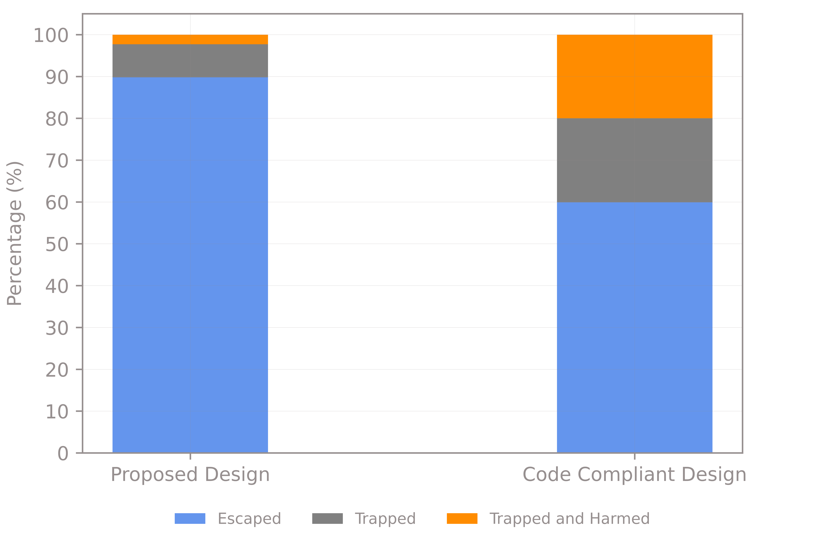

Figure 11: Relative Probabilities of an Occupant Being Trapped or Harmed Should Fire Occur Within the Kitchen Area

* + 1. These results show:
* The levels of safety for both proposed apartment designs is reasonably high;
* The likelihood of an occupant being harmed, should a fire occur, has been found to be higher in a code-compliant design than in the proposed design;
* The likelihood of an occupant being trapped within the demise, should a fire occur, is higher in the code compliant design than in the proposed design.
  1. Conclusion
     1. Therefore, as the results quantitatively demonstrate that the proposed design provides a higher level of safety than a code-compliant equivalent design, it is our view that the design can be assumed to comply with the Part B1 requirements of Part B of the Building Regulations.

1. References
2. **Approved Document B:** Fire safety Volume 1 – Dwellinghouses. 2020 Edition.
3. **Building Regulations 2010**. - Statutory Instrument 2000. HMSO, 2010.
4. **Open Plan Flat Layouts.** Assessing Life Safety in Fire. NHBC Foundation. 2009.
5. **FDS Version 6.7.7**. NIST.
6. **NIST Special Publication 1018-1**. Sixth Edition. Fire Dynamics Simulator. Technical Reference Guide. 18/11/2015.
7. **BS 9251:2021** - Fire sprinkler systems for domestic and residential occupancies. Code of practice.
8. **BS EN 12845. 2015**. Automatic sprinkler systems. Design, installation and maintenance.
9. **BS 5839: Part 6: 2019** - Fire detection and alarm systems for buildings. Code of practice for design, installation and maintenance of fire detection and fire alarm systems in dwellings.
10. **BS 9991: 2015.** Fire Safety in the design, management and use of residential buildings. Code of Practice.
11. **BS 7974: 2019**. Application of fire safety engineering principles to the design of buildings – Code of practice
12. **“Fire Load Survey of Historic Buildings"** taken from the Journal of Fire Protection Engineering, Vol 17.2, May 2010.
13. **SFPE Handbook of Fire Protection Engineering**. 2016. Fifth Edition.
14. **Fire Safety Design of Open Plan Apartments in England**. Architectural Engineering and Design Management. Charlie Hopkin. 2020.
15. **CIBSE Guide E.** Fire Engineering. Third Edition. 2019. The Chartered Institution of Building Services Engineers. London.
16. **PD 7974-1:2019 -** Application of fire safety engineering principles to the design of buildings - Initiation and development of fire within the enclosure of origin (Sub-system 1).
17. **BS 8214:2016** - Timber-based fire door assemblies. Code of practice.
18. **PD 7974-6:2019 -** Application of fire safety engineering principles to the design of buildings - Human factors. Life safety strategies. Occupant evacuation, behaviour and condition (Sub-system 6).
19. **PD 7974-7: 2019+A1:2021**. Application of fire safety engineering principles to the design of buildings. Probabilistic risk assessment.
20. **“Principles of Fire Behavior”**. Second Edition, 2016. James G. Quintiere.
21. https://www.gov.uk/government/statistics/detailed-analysis-of-fires-attended-by-fire-and-rescue-services-england-april-2020-to-march-2021
22. **“SCA Guidance on CFD analysis for Smoke Control design in Buildings”.** Smoke Control Association. Edition 1, January 2021.
23. “Open plan apartments – revisiting risks in light of contemporary demands”. International Fire Professional, November 2016, Issue No 18.
24. **BS 12101-6:2005** – Smoke and heat control systems. Part 6: Specification for pressure differential systems – Kits.
25. C. Hopkin and M. Spearpoint, ‘Numerical simulations of concealed residential sprinkler head activation time in a standard thermal response room test’. Building Services Engineering Research and Technology, 2020.
26. An Introduction to Fire Dynamics, 3rd Edition. Dougal Drysdale. 2011.

1. Heat Release Rate Graphs

Figure 12: CC1 – Programmed and Recorded Heat Release Rates

Figure 13: CC2 - Programmed and Recorded Heat Release Rates

Figure 14: PD1 - Programmed and Recorded Heat Release Rates

Figure 15: PD2 - Programmed and Recorded Heat Release Rates

1. Detailed Results Graphs
   1. CC1

Figure 16: CC1 - Visibility and Probability of Escape

Figure 17: CC1 - Smoke Temperature and Probability of Escape

Figure 18: CC1 – Radiative Heat Flux and Probability of Escape

* 1. CC2

Figure 19: CC2 - Visibility and Probability of Escape

Figure 20: CC2 - Smoke Temperature and Probability of Escape

Figure 21: CC2 – Radiative Heat Flux and Probability of Escape

* 1. PD1

Figure 22: PD1 - Visibility and Probability of Escape

Figure 23: PD1 - Smoke Temperature and Probability of Escape

Figure 24: PD1 – Radiative Heat Flux and Probability of Escape

* 1. PD2

Figure 25: PD2 - Visibility and Probability of Escape

Figure 26: PD2 - Smoke Temperature and Probability of Escape

Figure 27: PD2 – Radiative Heat Flux and Probability of Escape

1. Step By Step Calculation of Occupant Location Probabilities
   * 1. The probability of an occupant being in a particular room when fire occurs have been calculated using a simplified form of the data given in the NHBC/BRE study report. Specifically, the data has been simplified as follows:

* The calculations only accounts for an adult population. It is assumed that children will need to be escorted from the premises and that the time taken for carers to reach their children and prepare them for escape is already accounted for in the pre-movement time calculations (which are derived from work by Proulx).
* Similarly, bedridden and disabled occupants are not explicitly considered in this report. In the NHBC/BRE study, these occupants are required to be escorted from the premises by ambulant occupants rather than attempting escape themselves. As such, it is assumed that the time taken for an ambulant occupant to do this is accounted for in the premovement time. Scenarios where bedridden and disabled occupants live alone and are unable to escape are not accounted for in this study. However, if they were to be this would favour the proposed design cases, which tend to show tenable conditions being maintained in the demise indefinitely. Therefore, not accounting for this situation is considered conservative.
* The NHBC/BRE study also accounts for elderly occupants who have a slower walking speed and often need to be “led” from the house. For simplification, these occupants are simply assumed to have the same characteristics as the rest of the adult population.
  + 1. It is considered that any inaccuracies caused by these assumptions will have a negligible impact on the results given the comparative nature of the study. A step by step overview of how the assumed probabilities of an occupant being in a particular room were derived from the data in the NHBC / BRE report is provided below.
    2. Table 16 of the NHBC/BRE Study report provides the probabilities that both employed and unemployed occupants will be at home at different times of the day. These values have been divided into weighted averages in the final column of the table below.

|  |  |  |  |  |  |  |  |
| --- | --- | --- | --- | --- | --- | --- | --- |
| **Time** | 0:00 – 4:00 | 4:00 - 8:00 | 8:00 – 12:00 | 12:00 – 16:00 | 16:00 – 20:00 | 20:00 – 0:00 | **Weighted Average** |
| Employed | 1 | 1 | 0 | 0 | 0.4 | 0.8 | **0.53** |
| Unemployed | 1 | 1 | 0.7 | 0.7 | 0.85 | 0.8 | **0.84** |

Table 9: Table 16 of NHBC/BRE Study Report with Weighted Averages Column Added

* + 1. Table 15 of the NHBC/BRE Study report provides the probabilities of which room both employed and unemployed occupants will be in if they are at home both when they are awake or asleep. This table is included below.

|  |  |  |  |  |
| --- | --- | --- | --- | --- |
| **Room Type** | **Employed** | | **Unemployed** | |
| **Awake** | **Asleep** | **Awake** | **Asleep** |
| Bedroom | 0.2 | 0.97 | 0.3 | 0.97 |
| Lounge | 0.8 | 0.03 | 0.6 | 0.03 |
| Kitchen | 0 | 0 | 0.1 | 0 |

Table 10: Table 17 of NHBC/BRE Study Report

* + 1. By multiplying each of these values with the weighted averages calculated in Table 9 above, probabilities that an occupant is at home and in a particular room, both when they are awake or asleep can be calculated, as shown below.

|  |  |  |  |  |
| --- | --- | --- | --- | --- |
| **Room Type** | **Employed** | | **Unemployed** | |
| **Awake** | **Asleep** | **Awake** | **Asleep** |
| Bedroom | 0.11 | 0.52 | 0.25 | 0.82 |
| Lounge | 0.43 | 0.02 | 0.51 | 0.03 |
| Kitchen | 0.00 | 0.00 | 0.08 | 0.00 |

Table 11: Table 10 Multiplied by the Weighted Averages Given in Table 9

* + 1. Tables 15 of the NHBC/BRE Study report provides the probabilities that both employed and unemployed occupants will be asleep at different times of the day if they are at home. These values have been divided into weighted averages in the final column in the table below.

|  |  |  |  |  |  |  |  |
| --- | --- | --- | --- | --- | --- | --- | --- |
| **Time** | 0:00 – 4:00 | 4:00 - 8:00 | 8:00 – 12:00 | 12:00 – 16:00 | 16:00 – 20:00 | 20:00 – 0:00 | **Weighted Average** |
| Employed | 1 | 0.95 | 0 | 0 | 0 | 0.25 | 0.37 |
| Unemployed | 1 | 0.95 | 0 | 0 | 0 | 0.3 | 0.38 |

Table 12: Table 15 of NHBC/BRE Study Report

* + 1. Using these weighted averages, the probability of both unemployed and unemployed occupants being in any particular room when they are in the dwelling can be calculated, as shown below.

|  |  |  |
| --- | --- | --- |
| **Room Type** | **Employed** | **Unemployed** |
| Bedroom | 0.26 | 0.46 |
| Lounge | 0.28 | 0.33 |
| Kitchen | 0 | 0.05 |

Table 13: Table 11 Multiplied by the Weighted Averages Given in Table 12

* + 1. Figure 33 of the NHBC study states that of the adult population, there is a 0.65 probability that an adult is employed (if disabled occupants are multiplied out). Given this, the probability of an occupant being at home and in a particular room type are as follows.

|  |  |
| --- | --- |
| **Room Type** | **Probability** |
| Bedroom | 0.33 |
| Lounge | 0.29 |
| Kitchen | 0.02 |

Table 14: Probability of an Occupant Being at Home and in a Particular Room Type.

* + 1. As it would not yield any benefit to run an escape calculation for occupants who are not at home, these figures have been increased on a weighted basis so that their sum is 1 (i.e. it is assumed that there is always an occupant in the dwelling).

|  |  |
| --- | --- |
| **Room Type** | **Probability** |
| Bedroom | 0.51 |
| Lounge | 0.46 |
| Kitchen | 0.03 |

Table 15: Probability of an Occupant Being in a Particular Room Type Whilst at Home

1. FED Calculation Approach
   1. FED – Heat (Smoke Temperature and Radiative Heat Flux)
      1. The FED for heat is calculated at each timestep using Equation 10 of BS 7974:6 (below).

where:

= Fractional Effective Dose at timestep.

= Tolerance time for the level of radiative heat flux imposed at this timestep (minutes)

= Tolerance time for the smoke temperature imposed at this timestep (minutes)

= length of timestep (one second, or 1/60 minutes).

* + 1. The tolerance time for radiation () is calculated using Equation 7 of BS 7974:6:

where:

= Tolerance time for the level of radiative heat flux imposed (minutes)

= Radiant heat exposure endpoint for exposed skin (taken to be 1.33(kW.m2)4/3min. This is the minimum value for severe skin pain as per Table 2 of BS 7974:6

= Measured radiative heat flux (kW/m2)

* + 1. The tolerance time for smoke temperature () is calculated using Equation 9 of BS 7974:6:

where:

= Tolerance time for the smoke temperatures imposed (minutes)

= Measured temperature (°C)

* + 1. It should be noted that these temperatures are only valid where the moisture content of the air is <10% (v/v). Where the smoke is laden with moisture, such as where fire-fighting activities or activation of suppression systems have led to large quantities of water being added to the fire, studies have shown that it is difficult to breathe air with a temperature greater than 60°C. For this reason, point measurement devices measuring the water content of the air were added within the escape routes of the models. In all cases, the water content of the air was recorded as <10% throughout the simulations, so the above methodology is considered valid.
    2. This method of assessing the effect of heat on the ability of an occupant to escape is broadly similar to that adopted in the NHBC/BRE study.
  1. FED – Smoke Toxicity
     1. The FED for heat is calculated at each timestep using Equation I.4 of BS 7974:6 (below).

where:

= Fractional Effective Dose at timestep.

= Fraction of an incapaciting dose of CO.

= Assumed breathing rate of the individual (L/min) – This is taken to be 25l/min as per Table I.2 of BS 7974:6 for occupants “walking to escape”.

= Multiplication factor for CO2 induced hyper-ventilation.

= length of timestep (one second, or 1/60 minutes).

* + 1. The fraction of an incapaciting dose of CO () is calculated based on the concentration of CO measured in the model using Equation I.5 of BS 7974:6, as follows:

where:

= Fraction of an incapaciting dose of CO.

= Measured concentration of CO (µl/l at 20°C).

= Exposure dose (%COHb) for incapacitation. This is taken to be 30%COHb as per Table I.2 of BS 7974:6 for occupants “walking to escape”.

* + 1. The multiplication factor for ventilatory stimulation caused by CO2, , is calculated based on the concentration of CO2 measured in the model using Equation I.7 of BS 7974:6, as follows:

where:

= Measured concentration of CO2 (% v/v at 20°C).

* + 1. The study only accounts for the effects of the concentrations of gases CO and CO2 to calculate the FED value. HCN has not been included as Table B.2 of BS 7974:PD1 shows that most fuels likely to be present in significant quantities in a domestic setting do not typically yield a significant quantity of HCN when burned. Whilst this is a simplified assumption, it is a simplification which will favour the code compliant cases, which tend to have a higher rate of heat release and, therefore, would release a greater quantity of HCN into the domain.

1. Sprinkler Activation Time Calculations
   1. Objectives
      1. The objective of this assessment is to calculate a “worst case” peak heat release rate of a sprinkler controlled fire in the open plan area modelled. This figure will then inform the CFD modelling. To do this, the sprinkler activation time for a fire which originates in the open plan living area has been studied.
   2. Fire Location and Properties
      1. It is assumed that this fire will exhibit a “medium” fire growth rate (as per the report) and will originate on the floor (i.e. the height of rise of the plume is at its maximum).
   3. Sprinkler System Properties
      1. As per the work of Hopkin and Spearpoint[24], an RTI of 290m0.5s0.5 has been adopted for this assessment to account for the fact that the sprinklers are concealed. The activation temperature of the heads is 68°C.
      2. The radial distance to the sprinkler head is taken to be 2 in both cases. This is a rounding up of the worst case radial distances shown on the drawings. This is a worst case for a BS 9251 compliant sprinkler system layout based on the geometry of the dwelling.
      3. The activation time is calculated using a zone model (i.e. a hand calculation rather than the CFD model) and Alpert’s correlations (which are set out in more detail below). The zone model is used to predict the temperature and evolution of the smoke layer in the room, taking into account the geometry and fire growth rate.
   4. Calculation of Smoke Layer Temperature (Zone Model)
      1. The calculations below are deployed at one second intervals to allow the build up of temperature at high level within the room to be measured over time. The calculations are taken from Drysdale[25]. The temperature of the smoke produced by the fire as it reaches the ceiling is dependent on the convective portion (70%) of the heat release rate of the fire () and the mass of the smoke after ambient air has been entrained into the plume (). The heat release rate at each time step is calculated using a “medium” t2 fire. The mass of the smoke within the plume is calculated as follows:

*where:*

*= Mass of Smoke as it Reaches the Ceiling (kg/s)*

*g = Acceleration Due to Gravity (9.81 m/s2)*

*ρ∞ = Density of Air at Ambient Temperature (1.1 kg/m3)*

*cp = Specific Heat Capacity of Air (1.04 KJ/kg.K)*

*T∞ = Ambient Temperature (293K)*

*= Convective Heat Release Rate of the Fire (kW)*

*z = The Height of Rise of the Smoke Plume (m)*

* + 1. The temperature of the smoke plume as it hits the ceiling can then be calculated using the following formula from Drysdale:

*where:*

*= Temperature of Smoke as it Reaches the Ceiling (K)*

*= Convective Heat Release Rate of the Fire (kW)*

*= Mass of Smoke as it Reaches the Ceiling (kg/s)*

*cp = Specific Heat Capacity of Air (1.04 KJ/kg.K)*

*T∞ = Ambient Temperature (293K)*

* + 1. Using this, the change in temperature of the upper smoke layer for each time step can then be calculated using the following formula (Drysdale):

*where:*

*= Temperature Change in the Upper Smoke Layer (K)*

*= Temperature of Smoke as it Reaches the Ceiling (K)*

*= Temperature of Smoke Layer at Previous Time Step (K)*

*= Mass of Smoke as it Reaches the Ceiling (kg)*

*= Mass of Smoke in the Smoke Layer at Previous Time Step (kg)*

*T∞ = Ambient Temperature (293K)*

* + 1. The density of the smoke layer will vary as the temperature changes. This can be calculated as follows:

*where:*

*= Density of the Smoke Layer (kg/m3)*

*ρ∞ = Density of Air at Ambient Temperature (1.1 kg/m3)*

*T∞ = Ambient Temperature (293K)*

*= Temperature of Smoke Layer at Previous Time Step (K)*

* + 1. Using the above, the depth of the smoke layer can then be calculated using the equation below. This depth is then used to calculate the height of the previous equation.

*where:*

*= Change in Depth of the Smoke Layer (m)*

*= Mass of Smoke as it Reaches the Ceiling (kg/)*

*= Timestep Used for the Calculation (1 second, in this instance)*

*= Density of the Smoke Layer (kg/m3)*

*= The Floor Area of the Room (m2)*

* 1. Calculation of Sprinkler Activation Time
     1. Alpert’s correlations are used to calculate the activation time of the sprinkler based on the temperature of the smoke layer calculated by the zone model. These calculations are taken from CIBSE Guide E. As with the smoke model, these calculations are deployed at one second intervals. Using this method, the first step is to calculate the calculate the jet velocity (i.e. the velocity of the smoke as it travels across the ceiling), as a function of the growing heat release rate. This is calculated as follows:

U when r/H > 0.15

U when r/H <= 0.15

*where:*

*= Jet Velocity (m/s)*

*= Total Heat Release Rate of the Fire (kW)*

*= Height of the Sprinkler Above the Floor (m)*

*r = radial distance of sprinkler from the fire (m)*

* + 1. Using the jet velocity and the smoke layer temperature calculated by the zone model, the change in temperature of the sprinkler, accounting for the “Response Time Index” (RTI), is calculated using equation 11.5 (from Heskestad) found in CIBSE Guide E:

*where:*

*= Change in Sprinkler Temperature (K)*

*= Jet Velocity (m/s)*

*= Smoke Layer Temperature as Calculated by Zone Model (K)*

*= Previous Sprinkler Temperature (K)*

*= Response Time Index of Sprinkler (ms½)*

* + 1. The sprinkler is considered to have “activated” once the calculated temperature reaches its activation temperature.
  1. Calculation of Corresponding Heat Release Rate
     1. Once the detection time of the system is calculated, the corresponding heat release rate of the fire at system activation is calculated using the t2 fire method (i.e. time2 x fire growth rate coefficient).
  2. Peak Heat Release Rates
     1. The activation time of the sprinklers and the corresponding heat release rates were calculated and are shown in the table below.

|  |  |  |  |  |  |  |
| --- | --- | --- | --- | --- | --- | --- |
| **Room** | **Assumed Fire Growth Rate** | **Floor Area of Room (m)** | **Ceiling Height above Fire (m)** | **Radial Distance to Sprinkler (m)** | **System Activation Time (s)** | **HRR at Activation (kW)** |
| Kitchen | 0.047 | 25.0 | 2.5m | 2 | 185 | 402 |

Table 17: Calculated Sprinkler Activation Time

1. Programmed and Modelled Distributions for Behavioural Model
   * 1. For each scenario, the programmed and modelled distributions of pre-movement time, occupant staring location and occupant visibility tenability limit are provided in Table 17. It can be seen that the modelled distributions closely follow the programmed distributions.

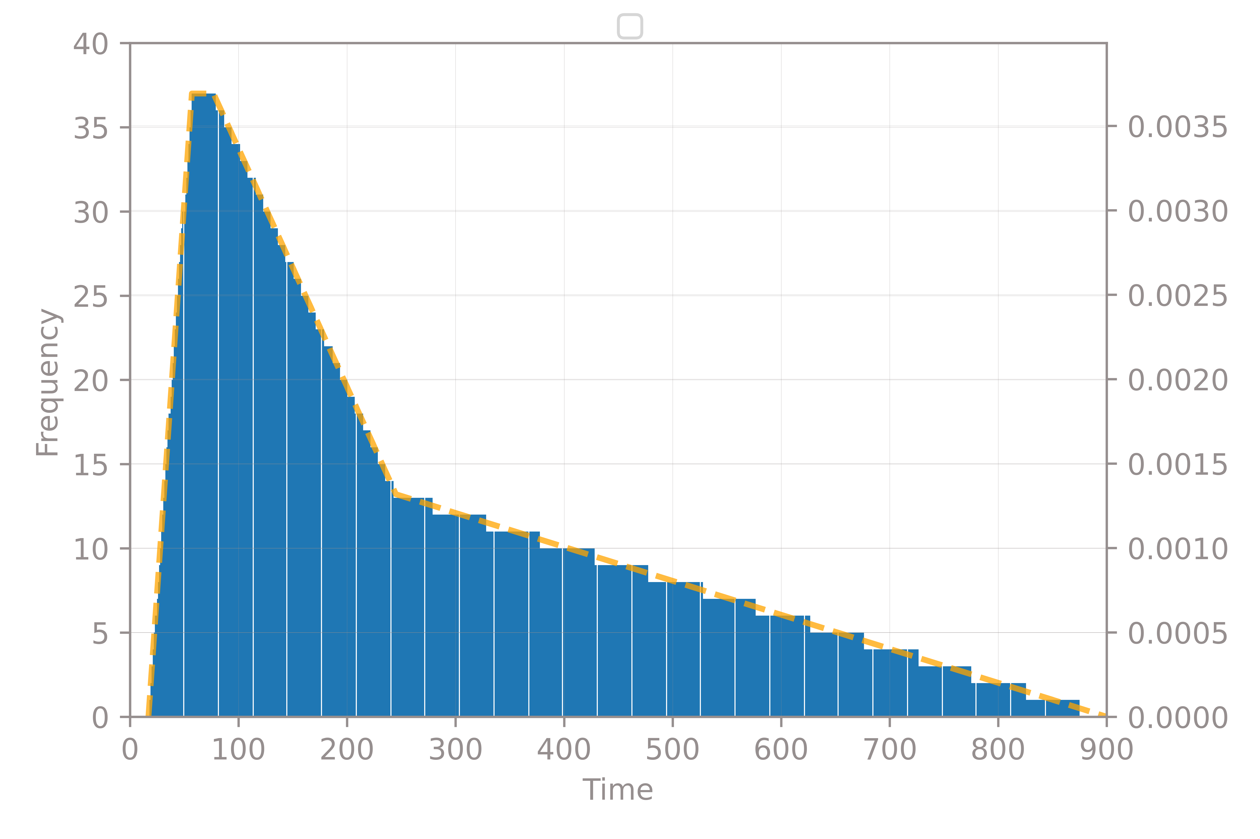

Figure 12: Pre-movement time distribution



Figure 13: Starting Location distribution



Figure 14: Visibility Tenability Limit distribution

1. Calculation of Number of Simulations Required for the Behavioural Model

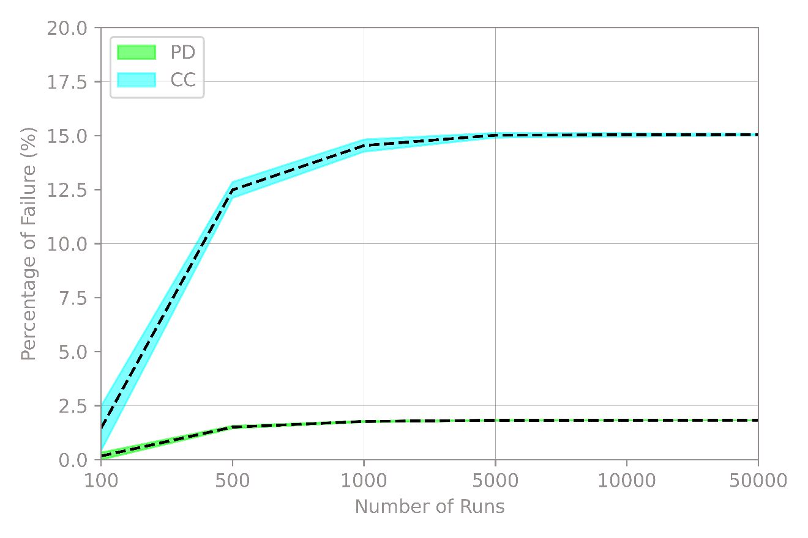

Figure 28: 8x10

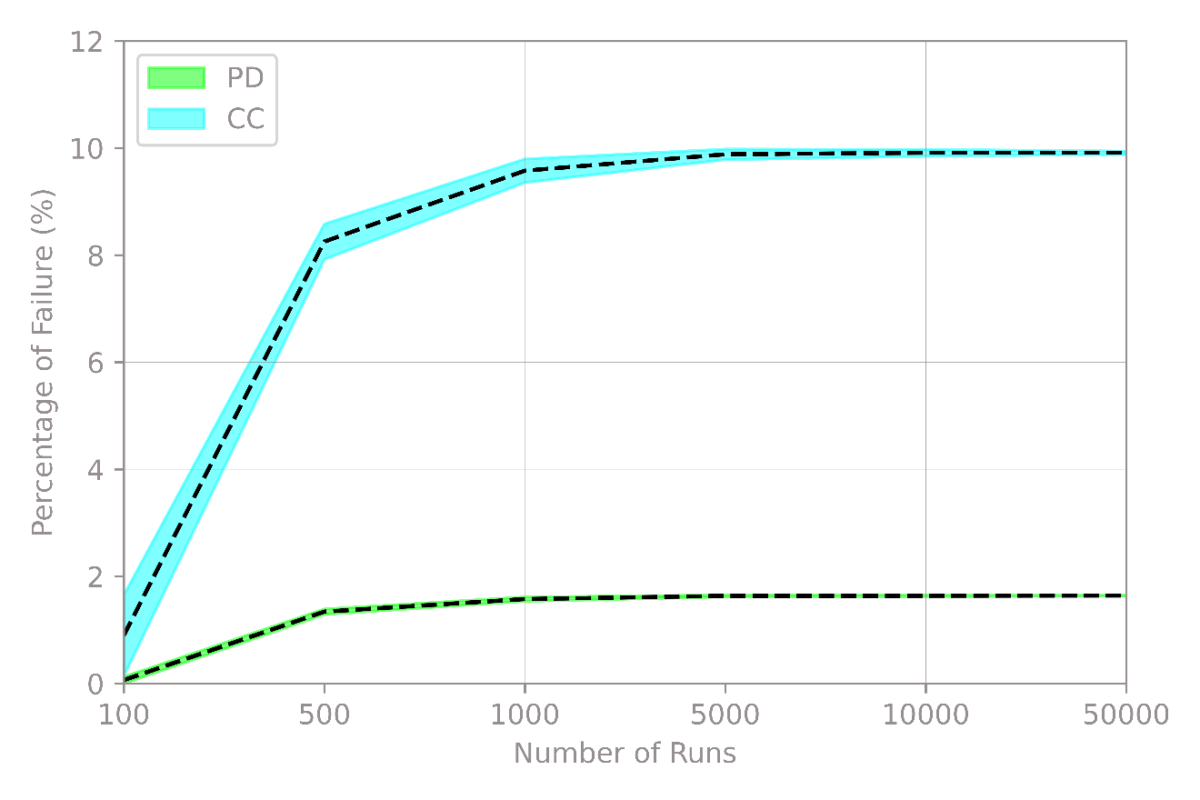

Figure 29: 12x16

